Mark Piland

CST 221

Memory Management

4/27/18

Github: <https://github.com/doom2053/CST-221>

**Memory Management Question 1**

Using the Memory Management Unit, also known as MMU, which is a hardware that you can help translate a virtual address to a physical address by passing each memory through the memory management unit which would be able to decide if the processes are able to continue between the disk and the memory for the transfer to happen. The Memory Management Unit is also able to help detect page faults as it would have to traverse through a serious of tasks to decide if it is possible to create. The Memory Management Unit works with the operating system by finding spare RAM to map the virtual address, but if there is no space left, then the virtual address would need to replace an existing page.

A psudo code for the MMU would be:

void

access (uint x, bool kernel, bool write)

{

if (!(x & PG_P)

=> page fault -- page not present

if (!(x & PG_U) && user)

=> page fault -- not access for user

if (write && !(x & PG_W))

if (user)

=> page fault -- not writable

else if (!(x & PG_U))

=> page fault -- not writable

else if (%CR0 & CR0_WP)

=> page fault -- not writable

}

// maps va => pa

uint

translate (uint va, bool kernel, bool write)

{

uint pde;

pde = read_mem (%CR3 + 4*(va >> 22));

access (pde, kernel, read);

pte = read_mem ( (pde & ~0xfff) + 4*((va >> 12) & 0x3ff));

access (pte, kernel, read);

return (pte & ~0xfff) + (va & 0xfff);

}

**Memory Management Question 2**

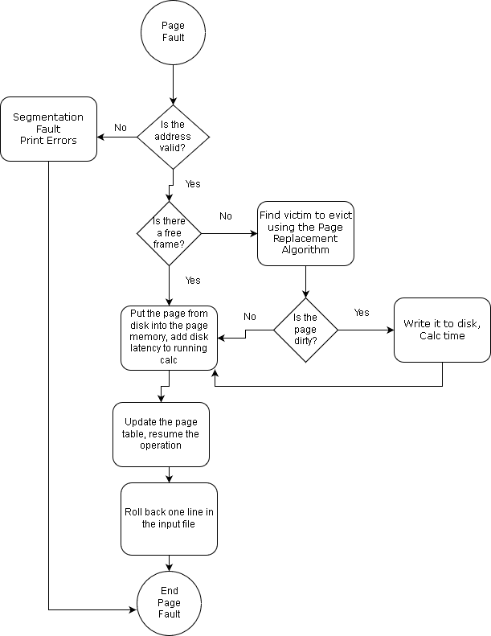

A Page Fault Handling is used to help determine if the virtual memory address is valid before it is to make a physical memory it is to go through a series of triggers but if there isn’t a free frame in the RAM you would need to replace a page with it using the Page Replacement Algorithm. The Page Fault Handler will be able to read the hardware to get the cause of the page fault and be able to do a series of actions to fix it by either killing the process if there is an invalid memory access or if it is a valid access, will only need to change the table which is a minor fault. A minor page fault can happen because of not enough in the user space but a major page fault can happen if the page isn’t present or if the cache is dropped.

**Memory Management Question 3**

The separation of mechanism and policy is extremely important when using the Memory Management Unit because it can provide a wider range when using the memory allocation by allowing a lot more flexibility when using the Memory Management Unit. The Page Fault Handler works with the Memory Management Unit because it is a serious of tasks that will decide if there is enough space in the memory to be able to bring a physical address, but if it can’t, it will use an algorithm to remove data off a selected page and replace it with what you are making physical. The external pager function evicts a the selected page chosen in the algorithm from the Page Fault Handler and it allows the server to not deallocate the page quick enough to cause a DOS and when it is done, it will swap the page with a double page.